Multiple-choice section

|  |  |  |  |  |  |  |  |  |
| --- | --- | --- | --- | --- | --- | --- | --- | --- |
| Question | 1 | 2 | 3 | 4 | 5 | 6 | 7 | 8 |
| Answer | C | A | B | A | B | D | C | D |

Question 1 [9.1]

C

3 + 9 + 2 + 6 = 20

Black:  × 2500 = 375

Orange: 375 × 2 = 750

Question 2 [9.2]

A

The mode is the score that occurs most frequently.

Question 3 [9.5]

B

The list of all possible outcomes is called the sample space.

Question 4 [9.6]

A

There are 52 cards altogether in a standard pack of playing cards. 13 are diamonds.

Probability of drawing a diamond:

= 

Question 5 [9.7]

B

In a Venn diagram, the notation used to represent the complement of *A* is *A*'.

Question 6 [9.5]

D

There are 20 numbers altogether and 6 of them are divisible by 3 (i.e. 3, 6, 9, 12, 15, 18).

Probability of drawing a number that is divisible by 3 is .

Question 7 [9.4]

C

Class centre = 

Question 8 [9.4]

D

a frequency distribution table

Multiple-choice total marks: 8

Short answer section

Question 9 2 marks [9.7]

(a) A *Venn diagram* can be used to work out the probability of an event occurring.

(b) The *union* of *A* and *B* includes the outcomes that are in *A* or *B* (or both).

Question 10 2 marks [9.1]

A population is the entire number of objects in a category. It often refers to people, but in statistics it is used to describe any defined category, such as birds, insects, light globes, vases, cars.

Question 11 2 marks [9.1]

Example 3 is a convenience sample because the nurses are in one place, so it is easy to see all of them at one time. It is also a judgement sample as people dealing with injuries have evidence to support their views.

Bias is very likely as, even though the group’s opinions may be valid, it doesn’t mean they reflect opinions held generally in the community.

Question 12 3 marks [9.6]

(a) 1 – (0.12 + 0.26 + 0.31 + 0.08 + 0.04 +0.02) = 0.17

|  |  |
| --- | --- |
| Children in the family | Probability |
| 0 | 0.12 |
| 1 | 0.26 |
| 2 | 0.31 |
| 3 | **0.17** |
| 4 | 0.08 |
| 5 | 0.04 |
| > 5 | 0.02 |

(b) (i) Pr(1 or 2)= 0.26 + 0.31 = 0.57  
0.57 × 850 = 484.5  
485 families

(ii) Pr(3 or more) = 0.17 + 0.08 + 0.04 + 0.02 = 0.31   
0.31 × 850 = 263.5  
264 families

Question 13 5 marks [9.4]

|  |  |  |
| --- | --- | --- |
| *x* | *f* | *x × f* |
| 42  43  44  45  46 | 9  12  7  1  1 | 378  516  308  45  46 |
| Total | 30 | 1293 |

mean =  = 43.1

median is 15th/16th position: 43

mode: *f* = 12 ↔ *x* = 43

range = 46 – 42 = 4

Question 14 6 marks [9.3]

(a)

|  |  |
| --- | --- |
| Result | Frequency |
| 1–5  6–10  11–15  16–20  21–25 | 5  5  6  6  8 |

(b)

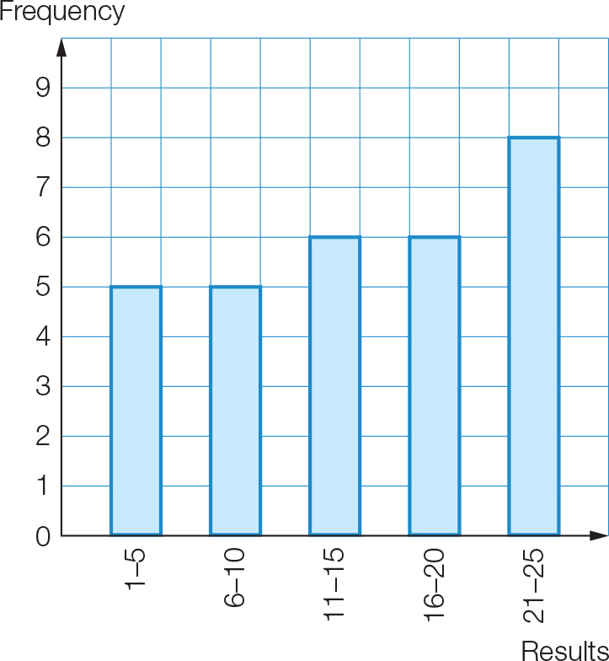

Question 15 2 marks [9.4]

(a) There are 20 data values. The median is between the 10th and 11th values.  
median = (153 + 156) ÷ 2 = 154.5

(b)



= 153

Question 16 2 marks [9.5]

(a) Pr(not 3 or 5) =  = 

(b) Greater than 2, i.e. 3, 4, 5, 6, 7, 8, 9, 10

Question 17 3 marks [9.6]

(a) Pr(M) = 

(b) Pr(consonant) = 

(c) Pr(T, E, A, M) = 

Question 18 4 marks [9.6]

(a) Pr(Jack or hearts) =  =  = 

(b) Pr(Jack of hearts) = 

(c) Pr(Jack or hearts but not both) =  = 

Question 19 3 marks [9.7]

Total number of students = 2 + 20 + 10 + 8 = 40

(a) Total number of students who play the guitar: 10 + 8 = 18  
Pr(*G*) =  = 

(b) Pr(*P* or *G*) =  =  = 

(c) Pr(*P* and *G*) =  = 

Question 20 4 marks [9.7]

(a)

|  |  |  |  |
| --- | --- | --- | --- |
|  | Fish | No fish |  |
| Rabbit | 14 | 10 | 24 |
| No rabbit | 4 | 2 | 6 |
|  | 18 | 12 | 30 |

(b) Pr(rabbit and fish) =  = 

Short answer total marks: 38

Extended answer section

Question 21 8 marks [9.3, 9.4]

(a)

|  |  |  |  |
| --- | --- | --- | --- |
| Class interval | *x* | Frequency (*f*) | *xf* |
| 25–<30 | 27.5 | 7 | 192.5 |
| 30–<35 | 32.5 | 9 | 292.5 |
| 35–<40 | 37.5 | 11 | 412.5 |
| 40–<45 | 42.5 | 14 | 595 |
| 45–<50 | 47.5 | 16 | 760 |
| 50–<55 | 52.5 | 19 | 997.5 |
| 55–<60 | 57.5 | 14 | 805 |
|  |  | Σ*f* = 90 | Σ*fx* = 4055 |

(b) Horizontal axis: 25, 30, 35, 40, 45, 50, 55, 60

(c) (i) estimated mean =  = = = 45.1 (1 d.p.)

(ii) modal class interval: *f* = 19 ↔ 50–<55

(iii) Both the 45th and 46th values are in the 45–<50 class interval.

Median class interval is 45–<50

Question 22 10 marks [9.1]

(a) (i) Set A: 2, 4, 9, 11, 4, 6, 2, 6, 2, 3. Mean =  = 4.9 letters per word  
Set B: 3, 6, 10, 5, 2, 3, 4, 3, 4, 3. Mean =  = 4.3 letters per word  
Set C: 2, 4, 11, 6, 2, 4, 2, 4, 3, 2. Mean =  = 4 letters per word  
Set D: 2, 4, 3, 3, 4, 2, 7, 3, 4, 3. Mean =  = 3.5 letters per word  
Set E: 4, 5, 2, 6, 3, 3, 2, 2, 9, 2. Mean =  = 3.8 letters per word  
Set F: 2, 4, 3, 3, 2, 4, 4, 1, 3, 7. Mean =  = 3.3 letters per word

(ii) Set A: Proportion with an ‘i’ =  = 0.2  
Set B: Proportion with an ‘i’=  = 0.3  
Set C: Proportion with an ‘i’=  = 0.1  
Set D: Proportion with an ‘i’=  = 0.2  
Set E: Proportion with an ‘i’=  = 0.2  
Set F: Proportion with an ‘i’=  = 0

(b) (i) Combined set A with B: Mean =  = 4.6 letters per word  
Combined set C with D: Mean =  = 3.75 letters per word  
Combined set E with F: Mean =  = 3.55 letters per word

(ii) Combined set A with B: Proportion with an ‘i’ =  = 0.25  
Combined set C with D: Proportion with an ‘i’ =  = 0.2  
Combined set E with F: Proportion with an ‘i’ =  = 0.4

(c) Sample size 10:  
Range of means: 4.9 – 3.3 = 1.6 letters per word  
Range of proportion with ‘i’: 0.3 – 0 = 0.3  
Sample size 20:  
Range of means: 4.6 – 3.55 = 1.05 letters per word  
Range of proportion with ‘i’: 0.25 – 0.1 = 0.15  
Variation of means and proportions both decreased with bigger sample size.

Extended answer total marks: 18

TOTAL test marks: 64